Student ID: S191345

Name: Adam Speers

Course: Computer Games Design

Assignment: Reflective Essay - Module Group Project [2017/18 Year] IMDCGD114-17YRD

Group 3 – Table for Two

**Introduction**

What were the key design decisions that were made in the production of the semester long game for this module, drawing on the readings you have undertaken this year, how successful were they and why?

To understand our key design decisions, we referred to the brief.

To summarise:

* 2D Game
* Main control mechanic is a simple tap
* Multiplayer – by taking turns
* On a single device
* Symmetric
* Simple and intuitive rules

With the gameplay experience as the focus:

* Engaging
* Focused
* Polished

**Key Design Decisions**

The first key design decision was what type of game we should produce, should we have a twitch mechanic and reward players with fast reactions, or should we develop something where more mental kill or strategy was required. Taking the brief into consideration we began by conducting research into our target audience for mobile games.

* Mobile Casual Gamers
* Gender: Female
* Age: 21-35
* 60-70% of the current market

We then looked at statistics for the type of game that this audience liked to play, we found that games where matching and memory were incorporated were particularly popular. And so, we chose to use these elements as our core mechanics.

**Game Theme**

We decide to use food and cooking as the themes to our game, games involving cooking and food had been identified as an area of interest in our target audience. The other reason for choosing this theme was that each member of the team liked the concept, and that when designing assets for the game that we could all contribute.

**Game concept**

Taking cooking as the theme**,** we had to decide on “The Most Important Rule pp.148” (Schell, 2008) the objective of the game. The objective for our game is:

Players take turns to memorise a recipe, they must then select the both the correct ingredients and amounts (within a specified time limit), select the correct cooking equipment and amount of actions to cook the recipe. Each correct selection will score the player points.

The player who most accurately remembers the ingredients, and the correct cooking steps accrues the most points and wins the round.

After a set number of rounds the overall winner is determined and wins the game.

**Mechanics**

**Game space:** To make the best use of the available game space considering a mobile game, we researched both the developer guidelines for iOS development and looked at some of the popular titles on both google play and iOS app store. This led to some key design decisions:

* Button size: The buttons a user should tap to select an ingredient should be sized so that they are approximately the same size as a fingertip.
* Button shape: As we were targeting a casual gaming audience we decided to use square buttons, these are the default buttons shape for the UI in all the most popular mobile platforms. Users of our game should be led by this familiarity and therefore find it more intuitive to know what to press.
* The game board would present to the player as a single player user interface in portrait. The games interaction buttons would be at the bottom of the screen. Once that players turn had ended the orientation of the game would flip. We did this as we envisioned that player would be playing the game on the same device facing one another.

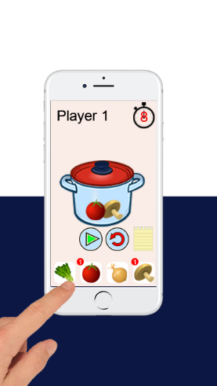 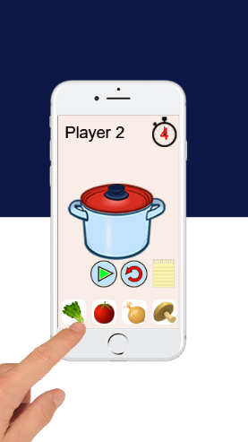

* Player feedback: In the screenshot you can see that each time a button is pressed a counter icon appears in the top right and counts how many times that button has been pressed. This allows the player to clearly see that their press has been registered by the game.
* Proxemics: In the scoring screen the players couple move towards one another as an indication of how well the player has cooked. The better the meal the closer the couple move to one another, symbolic of happiness and romance.

**Game Rules:**

We chose to use memory as the key mechanic for our game and there are a series of instructions presented to the player that they need to remember. To keep with the cooking theme a recipe card was chosen as the vehicle for presenting to the player the information that needed to be remembered.

When trying to decide how much and how quickly the player should be expected to remember things I did some research into short term memory. Which is uploaded onto Github (Speers, 2018).

The findings from this research was that we should try and limit the number of steps in a recipe to 7+/- 2 for the average person to be able to remember them. And that given this fact increasing or decreasing the number would be a useful way of controlling the apparent difficulty of the game. The game can be rewarding through this difficulty curve, and the player should be rewarded (Using the couple proxemics) if they manage to remember a particularly difficult recipe.

We also wanted to have the game Increase difficulty with each success / round. As the players play the game they would become more familiar with the recipes, they may remember a recipe from an earlier game. From the memory research we understand this to be the mechanism by which things transition from the short-term memory into intermediate term memory through repetition.

In addition to the number of items we also used the Stroop effect to increase the difficulty of the memory challenge, the players would read the recipe in text form and have to remember it, they would then need to pick the ingredients in pictorial form.

**Game Balance:**

When considering how to balance the game and keep it symmetric I considered the “12 most common types of game balance“ (Schell, 2008) And focussed on the first 2 of these.

1. Fairness
2. Challenge vs. Success

Our initial prototype used the same recipe card for each player, we thought that this would make the game fair, as both players would have the same ingredients to remember and recall. The challenge aspect would come in that as each round progressed the recipe would become harder, but this would be equally more difficult for each player.

**Playtesting Feedback**

We tried to playtest as often as possible during the 12-week lifecycle, the grid below was used to help assess player feedback.

|  |  |  |
| --- | --- | --- |
| **Mechanics** | **Dynamics** | **Emotions** |
| Do you understand what to do? | Are there to many items to remember? | Is it fun? |
| Do you understand whose turn it is? | Is the gameplay fast enough? | Schadenfreude? |
| Do you understand why you won / lost? | Is the game long enough? |  |
| Is the UI clear? |  |  |

When testing the game, I ensured that I got people to play who were not in our Game Design peer group and who were closer to our target demographic. A summary of the feedback comments from the initial prototype was as follows:

* “The game is too easy if I get the same recipe as them.”
* “Oh, is it my turn now”
* “Wait, if I’ve done that wrong can I go back?”
* “How do I know what I did wrong?”
* “There isn’t anything that isn’t in it, I can’t go wrong”

**Iterating on Feedback**

The player feedback was very useful and the changes to the initial key design decisions were:

1. A different recipe for each player.
2. Clearer indication of whose turn it was next
3. Clearer indication of the amount of time left
4. An undo button was added to the ingredient selection screen

The first change was to add a different recipe for each player, during play, player 2 would also read the recipe (even if upside down) and remember it. When it was their turn they were happy it was the same, it effectively doubled the time they had to remember & rehearse. We changed the game to ensure player 2’s recipe was likely to be different by making the recipe selection random. Occasionally the recipe would be the same however we felt this afforded opportunity for schadenfreude and so left this possibility in.

The second change was to introduce a clear transition screen when it was time to swap between players, this ensured that the next player was not disadvantaged by the other player keeping the handset whilst their timer was running.

The third change was to make it clearer to the players that they only had a set amount of time to perform actions. A new timer animation was added to make this obvious.

The fourth change was to add an undo button in the ingredient selection screen, this would allow players to correct a mistake if they had selected incorrectly, or had the other player poking the screen mischievously.

The final change was to add “Red Herring” ingredients to the selection screen to allow players to choose ingredients that hadn’t been on the recipe, this made it more important to read the card properly.

The importance of playtesting early was my key learning, some of our assumptions regarding fairness were incorrect as we hadn’t accounted for how players would observe each other during play.

**Conclusion**

I think our group was successful in meeting the brief for this project, we had good mechanics and the playtesting feedback was very positive, we could certainly carry on developing this game further and have a very good game with some more polish!

# Bibliography

Schell, J., 2008. *The Art of Game Design: A book of lenses.* 1st ed. Burlington: CRC Press.

Speers, A., 2018. *Group 3 - Memory Research,* Ipswich: UOS.